TRANS(PLANT) ON EARTH:
Ecological Crisis, Decolonial Education, and the Rise of the Dryad

Alek Zuniga de Dóchas
MFA Art & Ecology
Art Studio Qualifying Paper
April 2021

There was a moment in my undergrad at Pacific Northwest College of Art, during a class discussion, where I realized very suddenly and all at once how deeply connected my experiences are to the Earth’s. The course, called Religion and the Body, was a hybrid of Theology and Anthropology, and full disclosure, I was failing it despite my best efforts and genuine enthusiasm. Our professor had just assigned Jane Bennett’s Vibrant Matter: A Political Ecology of Things (2010) and our discussion was focused on the actant potential and vitality of nonhumans. One of the graduate students picked up a water bottle, “When I drop this onto the table, I affect the water. But at the same time, the water is affecting me. This exchange affects all of you. Without knowing it, the whole school, the cosmos themselves are affected.” My professor, an accomplished theologian and author, responded, “Now imagine a more volatile act, with more volatile actants, at a more volatile site. Imagine their effects.”
It was like a switch went off in my mind and I could finally comprehend the gravity of my actions, of my relationships to Others, and the way I related to them. What’s more, I began to consider the history of humanity since early modern European colonization and industrialism, and the intergenerational devastation that has resulted. It was in this course text that Bennett theorized, “…the image of dead or thoroughly instrumentalized matter feeds human hubris and our earth-destroying fantasies of conquest and consumption. It does so by preventing us from detecting…a fuller range of the nonhuman powers circulating around and within human bodies.” Which is to say that our human disconnect from nonhuman bodies is an extension and dire consequence of colonial ideology. I was consumed by wonder and horror. To be intrinsically linked to all forms of life and matter meant never being alone, but it also meant carrying the weight of an entire planet’s pain in some form within myself. How could I hold that knowledge, that feeling, that energy, and not be compelled to work towards healing and restoration for the Earth and its varied inhabitants? As political theorist Tim Morton posits, our “ecological reality requires an awareness that at first has the characteristics of tragic melancholy and negativity…but which evolves paradoxically into an anarchic, comedic sense of coexistence.” I wouldn’t have the knowledge or visual language yet, but this idea would become critical as I entered into my post-graduate artistic research.
It has been seven years since that class and that epiphany. My passion has stayed the same, but my concentration and direction are much clearer than that of the flighty nineteen-year-old who would clumsily practice druidism in the Portland woods to wane the emotional and spiritual unrest that they felt.
This document is a record of my studio practice and includes the most formative projects leading up to graduate school as well as those that I’ve produced up to this point in my program. Borrowing the language of many artists and scholars that have come before me, but with Dr. Kency Cornejo particularly in mind, I strive towards decoloniality in the function of my work and in the ways that I see and interact with this world which is institutionally controlled and dominated by Eurocentrism. My queerness, my transness, my economic status, my proximity to whiteness, all inform my academic and creative work as well and will undoubtedly inform readers’ interpretations of this paper. More than anything else though, this document will introduce the reader to a figure that has become indispensable and critical to the progression of my art and research, and to which my entire thesis is anchored: The Dryad. It is my hope that through this text, my qualification for advancement in the program is made clear and that the reader may find tragedy, anarchy, and joy in the actions of a curious Trans(plant) on Earth.
For the past several years, my studio practice has been focused on confronting viewers with the dark and unsettling history of violence that the Earth has experienced at the hands of humanity and introducing the Earth as a Queered (Celestial) Body. This journey began with material experiments, venerating the land by bringing soil, mud, and similar lifeforms into the gallery (or bringing the gallery to the land) to inherit the social “value” that is bestowed on Art. There is a long history of these or similar practices, such as those of the early participants in Land Arts or Earth Arts: Walter de Maria, Robert Smithson, and Claes Oldenburg, to name a few. And while they were my entry point into this type of work, these white men’s relationship to and manipulation of the Earth felt at times perverse and antithetical to my own understanding and appreciation of the land. At the height of their collective contribution in this area—their Earthworks exhibition at the Dwan Gallery, NY took place in 1968—there was still an under-interrogated desire for control over the environment, and it’s made clear in their artistic approaches.
This ideology hasn’t changed drastically in the fifty-or-so years that have passed, especially when one considers ever-present Eurocentric hierarchal concepts of subjecthood, ownership, and domination. However, I think back to the consequence of that earlier Bennett quote, and the scholarship of other contemporary educators, theorists, and activists. When we offer alternate ways of Knowing, even in the seemingly most innocuous context, it acts to liberate the colonized mind. There is plenty of decolonial dissent happening across the U.S. and the globe to have a considerable cosmological effect, as my former classmate framed it.
As I continued my work, I began to see the need to implicate myself directly in these Art Moments with the Earth. I engaged in site-specific performances, drawing wide-scale public attention to the tender care and courtesy I was giving to small twigs, clods of soil, fallen seed pods, etc. as with Earthforms (2017) and Trails I (2017). This quickly developed into more intimate encounters between my body and the Earth. Consuming and being consumed by Earth was a recurring visual narrative that I employed, drawing on Pre-Columbian conceptions of the land as being “womb and tomb” to humanity; as offering us sustenance, nourishment, and life, while also ultimately feeding on our flesh at the end of our days, and thus being venerated and respected for its dualistic power. These performances would usually involve me being caked in mud, soil, and the like either gradually or all at once, or producing these materials from my orifices in an apparent rite of transformation. This area of my practice was greatly influenced by my obsessive research of Ana Mendieta’s work, mostly her Silueta series (1973-78), which involved her body in a range of natural spaces in a gesture of spiritual connection to the land. However, I desired to more actively implicate the viewer in my performances. How could my body provoke audiences into action? To help me? To help the Earth?
In the year that followed, I would work towards the completion of my installation Body of Earth (2017), which included a series of mixed-media clay sculptures, an immense earthform in the middle of the space, and two interrelated videos that would prove to be a critical shift in my practice: The Golem and the Earth and The Dryad’s Plea, each 26 minutes in duration. In the former, a ghastly figure slowly emerges from a shallow grave and crawls towards the viewer, their motive unclear but unsettling, before time rewinds and the creature once more returns to the Earth. The film plays on endless loop, reflecting the cyclical nature of humanity’s relationship to the land and causing an acknowledgment of our most base role in the ecosystem. In The Dryad’s Plea (2017)—my first true engagement with the character who is now so vital to my practice—an ambiguously-gendered and seemingly faceless figure covered in mud stands in the middle of a white void with their arms outstretched like the Virgin Mary, beckoning to the viewer.
Body of Earth (Full Installation), 2017

However, this pose gradually shifts into a series of pleading gestures, the Dryad attempting to communicate their distress without a mouth to cry out from. About halfway through the film, the figure’s begging turns to wrathful fury, as the Dryad tears open a hole in their face to attempt a muted scream. Still unable to communicate their desperation, the creature then unleashes a wave of monstrous and frenzied attacks into the void that land with powerful reverberations. I was inspired by the creature depicted by Santigold in Wangechi Mutu’s animated video The End of eating Everything (2013), and how colossal, frightening, and hurt she looked as she consumed all life in the toxic landscape. I sympathized with it and felt that, like my creature, she was forced into this grotesque form by the deeds of humankind. This piece began my artistic journey into articulating the pain of the Earth through the anthropomorphic vessel of the Dryad, while also beseeching viewers to empathize with this uncanny, emotional, and queer monster-deity.
Before moving deeper into my work, I’d like to discuss the Dryad in more detail, as her appearance, demeanor, and origins are unlike most people’s notion of what a dryad should be. The Dryad (she/they) of course shares a namesake with the fairy-like wood nymphs that are more or less well known from Greek lore and western popular culture; but my (our) Dryad of today is a complete bastardization of that entity. She’s not a serene and dreamy spirit in some distant grove, but is instead more akin to a reanimated corpse, an amalgamation of mud and viscera given form from the bones of the Earth. Where the dryad of yesteryear harkens back to a locus amoenus and upholds the belief that Nature is some Romantic escape away from human activity, the Dryad of today was born directly out of the disorder of an Earth affected by human systems of oppression and exploitation. She represents a conception of Nature that is inclusive of all lifeforms but especially those most vulnerable and marginalized. She rejects the elusive and demands attention. She embodies an Earth that is screaming for a post-colonial and anti-imperial future and will do whatever nasty thing it takes to get there. The Dryad is an Earth queered by its malignment, mistreatment, and violence at the hands of colonial humankind, and her experience of othering informs her attitudes and actions in films, performances, or otherwise.
I have, in the past, attempted to move away from the title of “Dryad,” feeling apprehensive of the Eurocentric historical context that comes with it. But I quickly came to realize that it is that dialogue, that challenge, that mistreatment of our preconceptions of the Earth and its characterization that I was so excited about. Many western audiences hear “dryad” and have at least an inkling of an image in their head of what that looks like based on mythologies and fantasy stories throughout time. So, when they’re confronted with this very strange creature, they go “Wait, isn’t this a dryad over here?” to which I can impishly and indulgently reply, “No, they all got it wrong. Dryad’s right here, and she looks nothing like that!” Imagine the cultural consequence of a dryad being re-defined in this way after my misappropriation of the classical fantasy.
Central to my work is the juxtaposition I observe in the struggles of myself and fellow queer(ed) people living under Eurocentric systems of oppression, and the struggles of the Earth itself as it survives trauma after trauma from merciless, insatiable colonial powers. When I began to reframe ecological issues as queer issues, seeing the Earth as a universally-consequential Queered Body, it made my encounters with it—both in and out of my art practice—more personal and empathetic. This is the seed of inquiry that brought the Dryad into existence; finding a physical form onto which I transpose the micro and macro scales of oppression and othering faced in (and by) the world. Throughout the remainder of this paper, I will continue to expand upon the Dryad’s ideological and aesthetic roots by discussing specific works leading up to my current studio projects.
Following the feeling of breakthrough that came with The Dryad’s Plea, I started a much richer investigation into this curious new character that was eager to show herself in my practice. The Dryad became the subject of several photographic series, performances, and films; my sketchbooks were filled with new forms for her to take, as I wondered what she would do next to steal the hearts and attention of human art audiences. There was something so rousing and terrifying about her sense of urgency, as if she wanted to reach through phone and computer screens and vomit sacred ecological, cosmological knowledge down viewers’ throats. I wanted to do justice to her motivations. To paraphrase environmental writer, Emma Marris, I’ve spent my life within a colonial framework, contributing to an Earth that will never be the same because of it; so now I (we) cannot sit by and abandon it to a random fate. It is my (our) duty to manage its care. Like much of my work—where I felt as a collaborator to the Earth—this was a critical role to fill in order to bring about positive change, and it required careful consideration of my methods and tactics to do so.
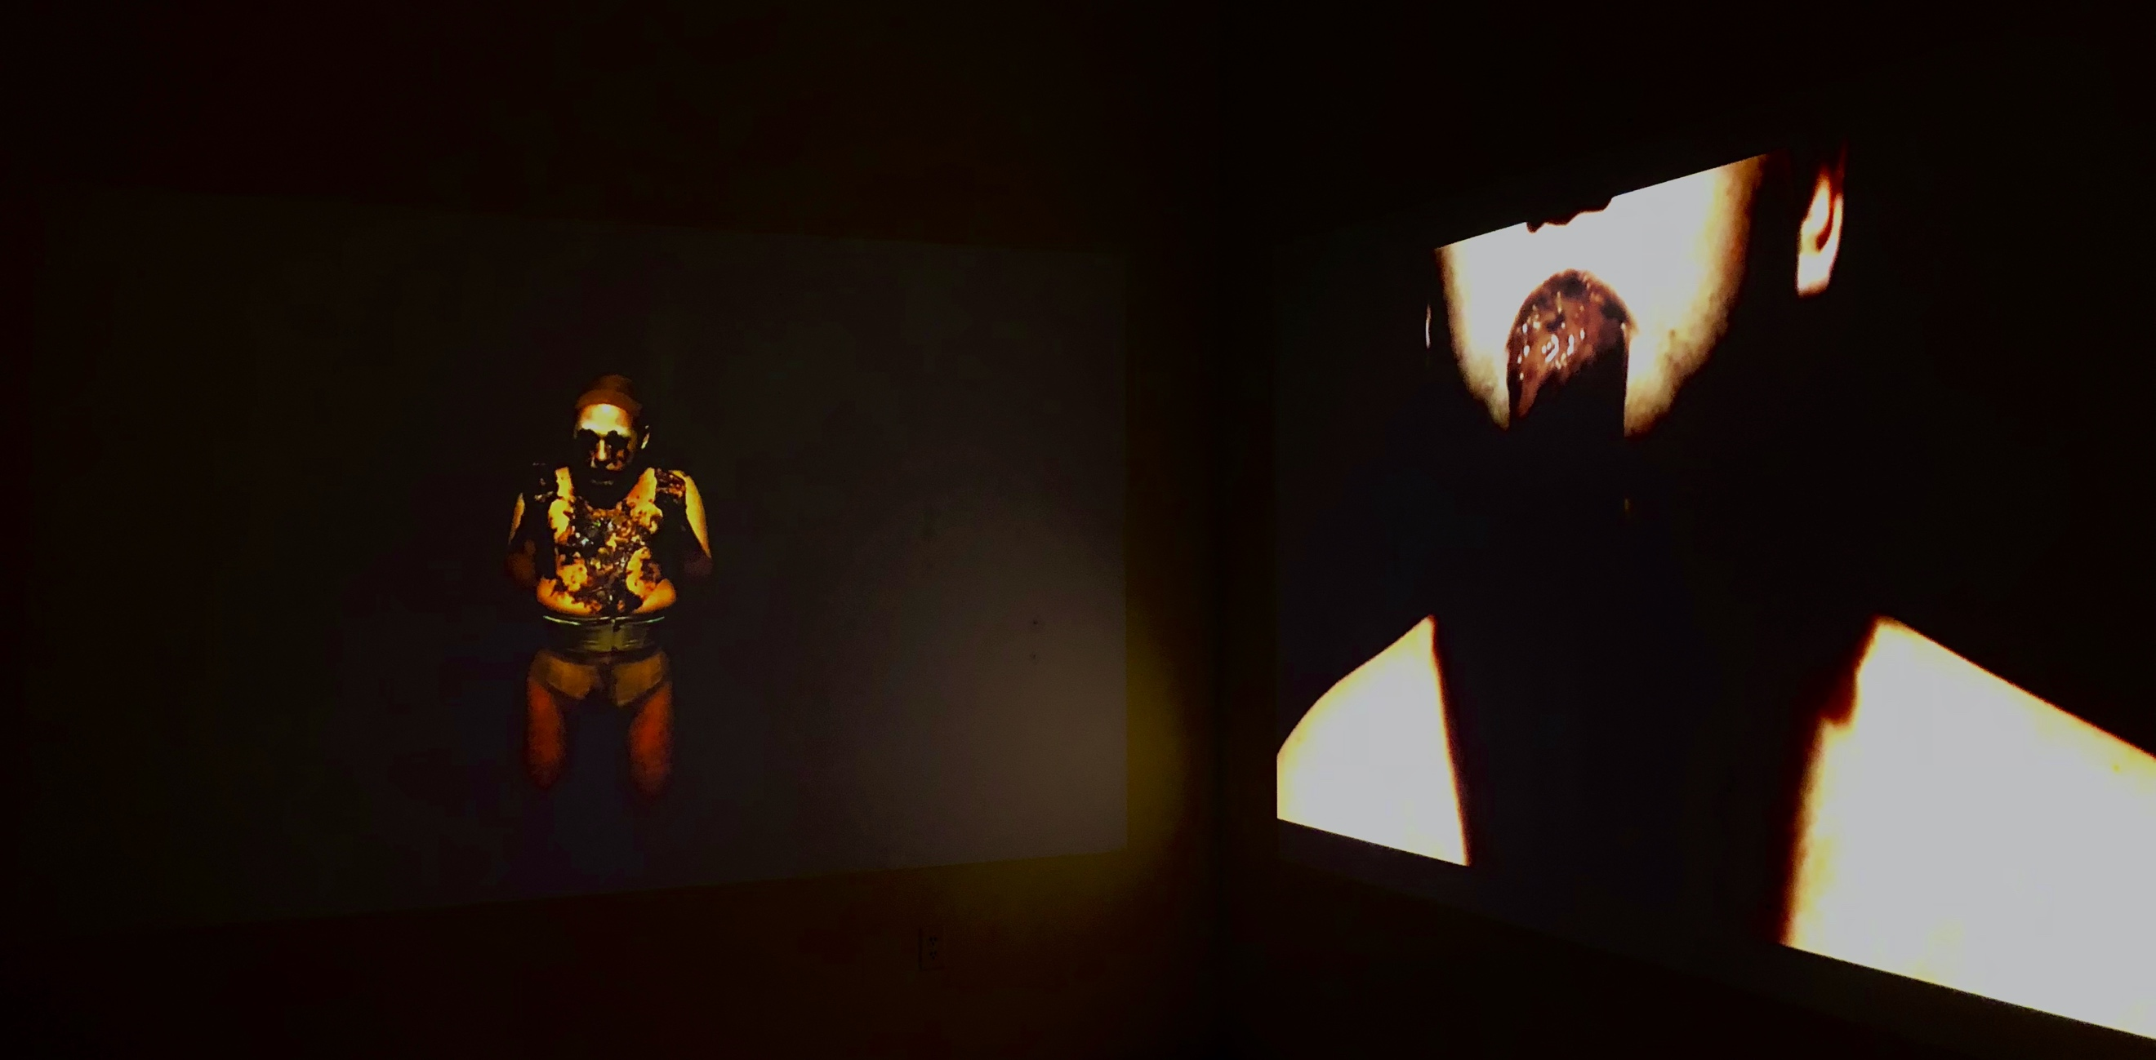
My next major work was Dryad’s Manifesto (2018). The thirteen-minute, two-channel video piece involved the emblematic figure engaging in a series of discordant movements and actions that explored the limitations of her humanoid vessel, as she produced and/or consumed a brown viscous substance. At the same time, an augmented voice recites the late eco-philosopher Arne Naess’ summative essay, “The Shallow and the Deep, Long Range Ecology Movement” (1973) while another voice—presumably Dryad’s—utters unnerving claims against humanity’s imperialist sickness and the Earth’s eagerness for retribution. The visual display was at times simultaneously or individually intimate, erotic, revolting, and disturbed while the audio sought to inform and radicalize human allies in the fight for the Earth. As I reflect on this work now, I’m reminded of philosopher and theorist Frantz Fanon, who stated that “imperialism…sows seeds of decay here and there that must be mercilessly rooted out from our land and from our minds.” The colonized disorder that violates body, mind, and the Earth itself, shows itself trifold in the Dryad and her struggle for autonomy. This approach would greatly influence the direction of my current work.
Dryad's Manifesto (installation view), two-channel video, 13 min duration, 2018

The Dryad is an extension not only of the Earth, but also me, a queer, trans-femme, Latinx creative worker from a lower-class background. The visual properties of the character are inspired, in part, by my affinity for alternative drag performance, punk rock, and horror and science fiction films, as well as queer-coded villains and monsters; I’ve been particularly inspired by the writing of Octavia E. Butler on the evocative nature of the Oankali’s relationship to humanity and Mary Shelley’s infamously scorned and hated Creature, driven to vengeance borne of misery. The Dryad is representative of the othered and the marginalized, the weird and the maligned. As revealed in post-performance and post-screening discussions, people from these subcultures become excited by Dryad’s presence because they see parts of themselves in her, and even if certain aspects of her being are unknown or alien to them, they’re willing to accept that in order to see what tantalizing and horrible thing she’ll do next. Although my audiences vary slightly from venue to venue and platform to platform, I’ve come to understand the importance of prioritizing the viewpoints and aesthetic values of the Queered with whom I and the Dryad find safety and community.
In the months preceding my entry into the Art and Ecology graduate program at UNM, I collaborated with the Sprite Artist Candace Rood on the video piece Testing Degradation (2019), which explored the complex dynamic between the Earth and the workers at nuclear waste processing sites, whose guided hands play a part in the steady decimation of the land. Though my character, the “Subject” was never formally named, they were certainly heavily informed by my work with the Dryad; they were an embodiment of a sickly and violated Earth, being force-fed repugnant concoctions in some strange, abusive series of trials to measure mental and physical limitations. The narration includes both, the “Subject” and “Masked Worker” expressing their respective fears, sorrows, and motivations, urging viewers to question their own proximity to this ecological violence and its inevitable effect on all we care for, starting with the most vulnerable.
Finishing this work in Fall 2019, it definitely painted the lens in which I viewed my practice moving forward. In this and other previous projects, there was a tense and gut-wrenching atmosphere, most usually involving Dryad (or Dryad-like characters) being subjugated to bodily trauma and enduring bizarre tests of consumption. While the mood of these performances was effective, I began to desire another layer of accessibility for viewers so that they could enter the work; many audiences can sit through only so much body horror and revulsion before needing some sort of gratification for their time and energy spent with the piece. After some experimentation with musicality and song—influenced by the intensity of Diamanda Galás—I arrived at a tentative solution: laughter. In particular, an unhinged and uncomfortable laughter at the expense of imperialist authority. Dryad was already basically a demented clown made up of dirt and bugs and trans(planted) flesh, so it seemed a logical next step to expand in this direction and become a primordial court jester who speaks on the wrongdoing of western colonial powers. Calling again upon political theorist Tim Morton’s concepts of “The Melancholy” and its inner region, “The Ridiculous,” I was greatly interested in “comedy with something missing,” which leaves room for both hilarity and misery.
Comedy has such a rich history and function as a critical tool for opening audiences up to the complex issues and systems that surround us. Laughter allows us to let our guard down and become open to the ideals shared by the humorist (or dirt-clown in my case), and I wanted to manipulate this power in the most absurd and stomach-turning ways that I could possibly expect viewers to withstand. The Dryad is, after all, not a contemporary comedienne in any respect. So, I had to consider what about this character has the potential to be funny, and how I could pair laughter with/at the Dryad to more perplexing, difficult visuals and underlying narratives in an effective manner. Naturally, at the precipice of this new creative venture—because fate always manages to have the last laugh—the world turned within itself and the COVID-19 pandemic spread its maw wide and clenched down upon humanity.
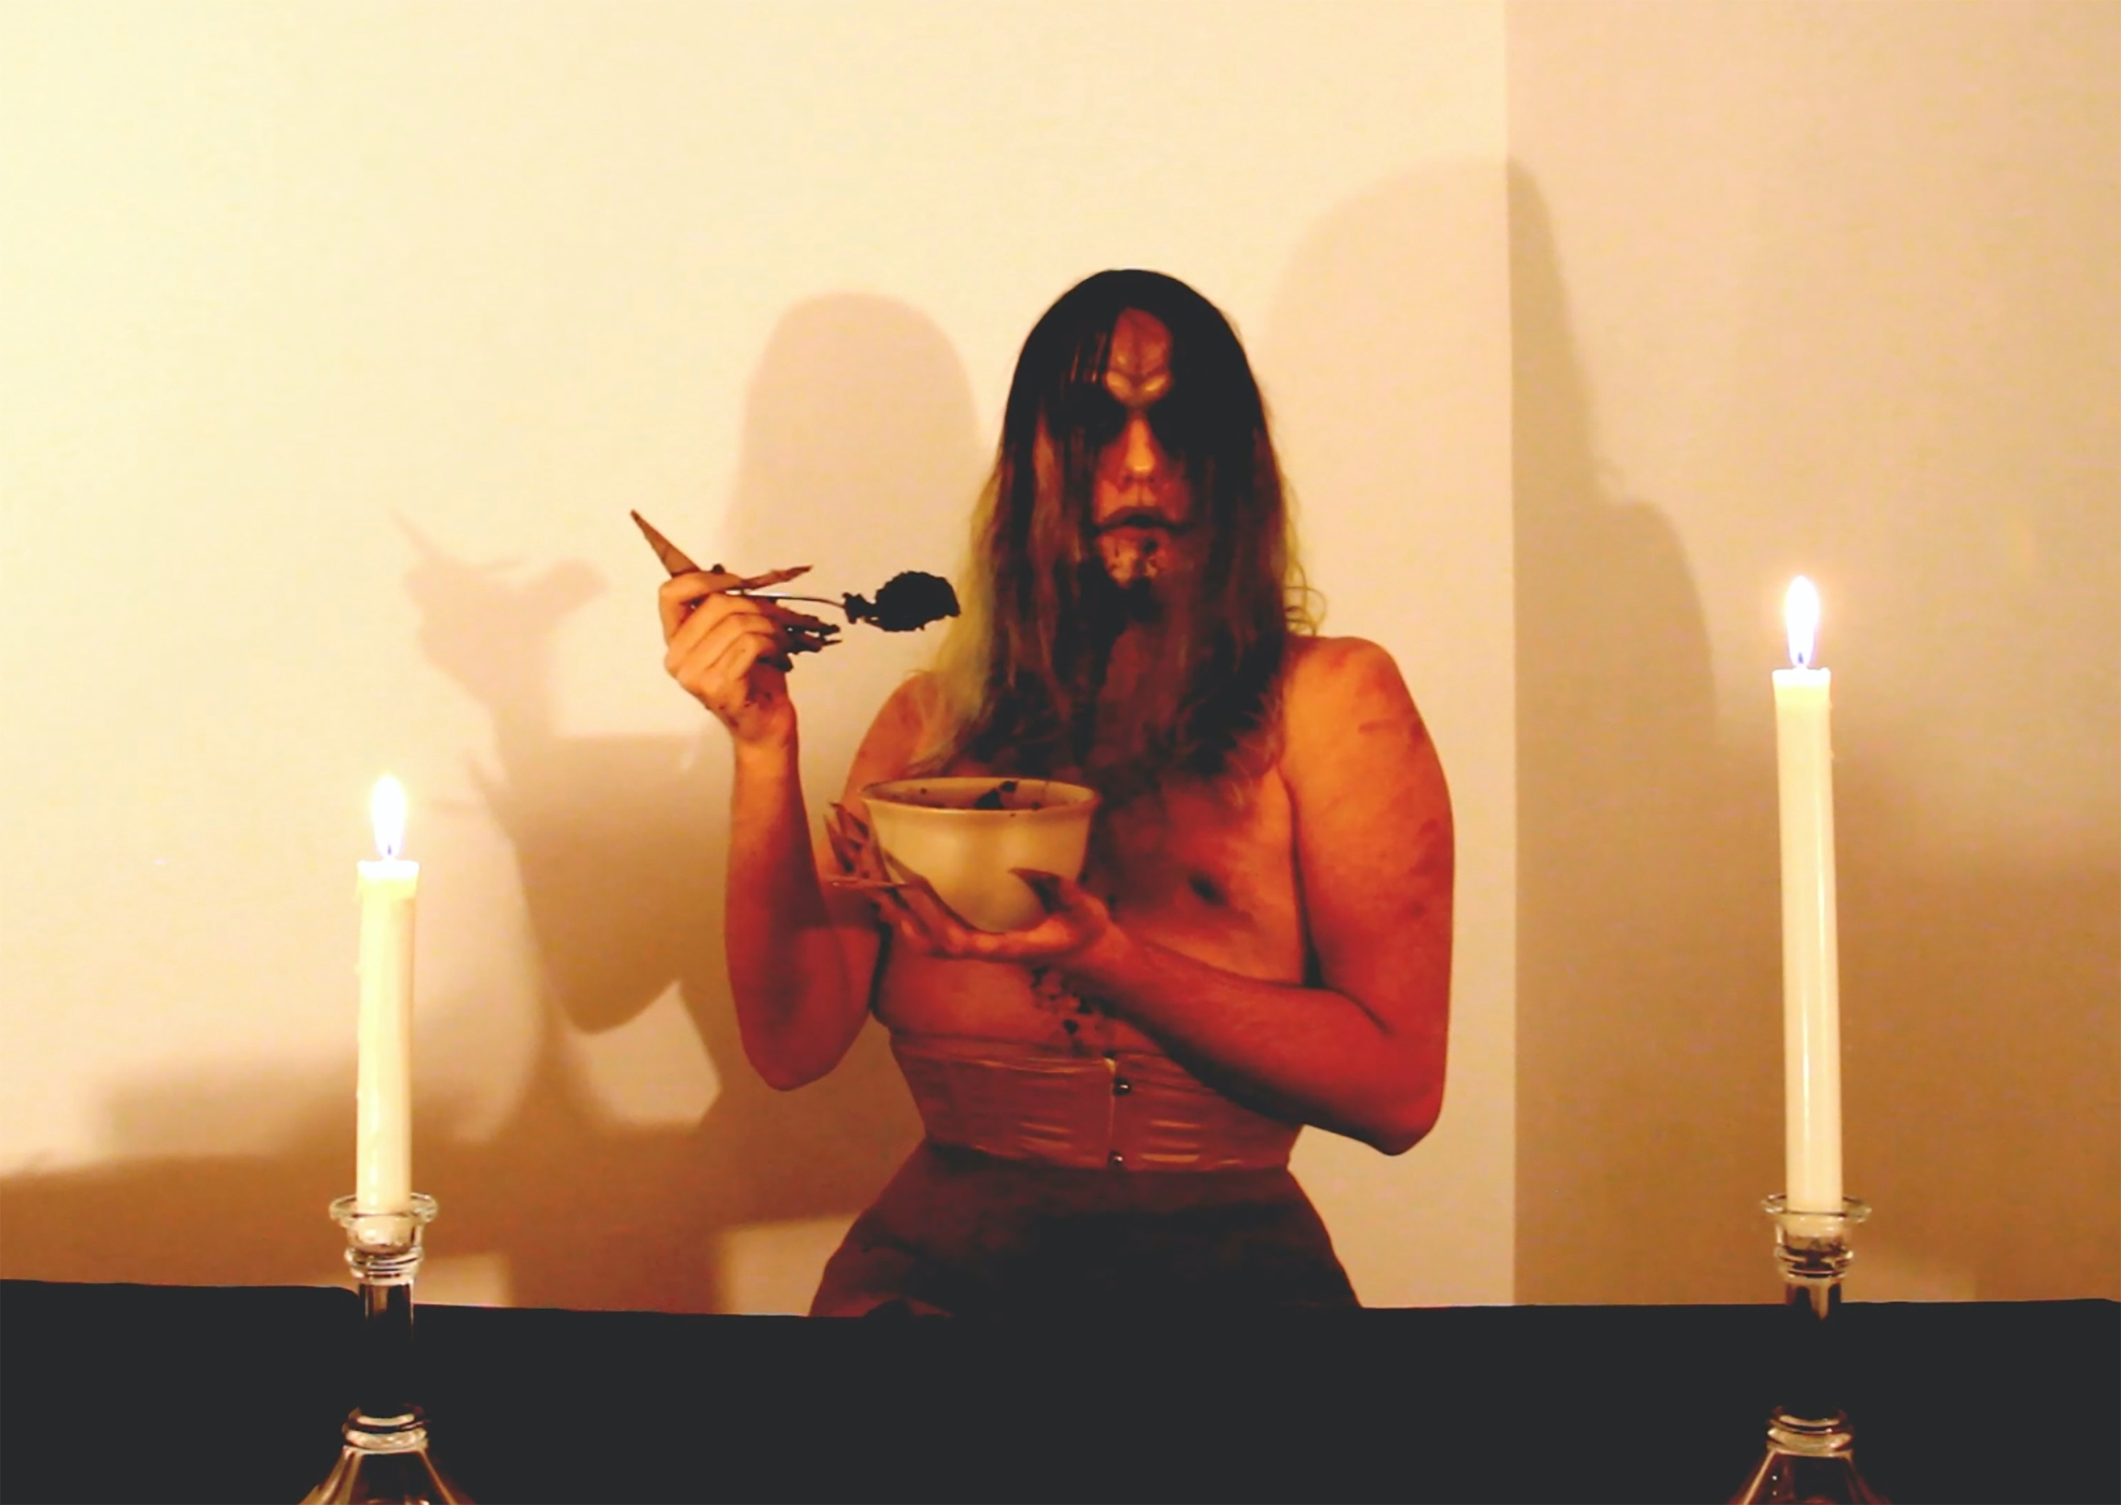
Facing severe personal and global loss, I was debilitated by the emotional weight of grief and isolation. Months would pass before I had the wherewithal to make art again, and my mind was clouded by the thick fog of melancholy and chaos that permeated every aspect of life in 2020. I tasted defeat and it was rotten. The only way forward, I concluded, would be to lean into those feelings through my studio work. Thus, I began the DRYAD EATS video archive.
DRYAD EATS IMPERIAL BULLSHIT, single-channel video, 6 min duration, 2020

The six-minute video, DRYAD EATS IMPERIAL BULLSHIT, was edited and produced with a mindset of unpredictability, outrage(ousness), contempt, and exhaustion. Given the increased shift to digital interaction during the pandemic, this piece marked my move towards creating work specifically for an online audience and my implementation of visual strategies and formulas utilized/recognized by different internet platforms and communities. I was drawn to the idea of the Dryad rising from her ancient tomb at the center of the Earth, seeking to change the fate of the planet and humanity through amassing devoted worshippers, only to arrive here in the 21st century where gaining a cult of followers is largely connected to your social media influence. How would the Dryad navigate this contemporary terrain in order to fulfill her role
and how would her strange, sultry, and dirty demeanor inform her approach in an entertaining way? (Through toilet humor and niche erotica as it would turn out.)
Appropriating elements of online “foodies” and mukbangs, pornographic cam shows, and internet meme culture, the Dryad engages in a candlelit dinner of “imperial bullshit,” which she gorges herself on to the point of vomiting. Her mood and physical behavior shift frantically from hyperbolically enthused—taking pseudo-seductive bites like a busty model on a Carl’s Jr. commercial—to undeniably revolted and undone by this task. The fast-paced and manic editing style recalls both my own state of mind at the time, as well as the general aesthetic and comedic values of online content creators and consumers. This film and the subsequent, DRYAD EATS THE PENTAGON (2020) make use of an audiovisual absurdity to engage viewers, either with something they’re familiar with or are at least intrigued by, to offset the at times menacing and alarming nature of Dryad’s presence. The intention with this body of work is to cultivate an audience’s investment in this queer creature’s ongoing antics in order to placate them and help them understand the ideological shift that Dryad impresses upon them as the series continues.
In the second video mentioned above, Dryad consumes a Devil’s Food cake haphazardly decorated to represent the headquarters of the U.S. Department of Defense, the Pentagon. With this blatantly political action, our beloved monster of the Earth destructively eats this symbol of the U.S. military which has historically contributed to violence against humanity globally in order to commit further violence against the environment and exploit the Earth’s resources. While the task of shoving the Pentagon down her throat is a necessary one, it wears on the Dryad, emotionally and physically. After struggling to keep the Devil’s Food down, she resorts to smashing the last remnants of the building in a thunderous fit.
These and other works have been influenced by my love and appreciation for the artistry of John Waters and perhaps specifically his collaboration with Divine in films such as Pink Flamingos (1972). The shock value and visceral effect of such iconic scenes as Divine closing the film by eating fresh dog shit off the sidewalk acts to scandalize and challenge audiences in this transgressive cinematic experience (as well as re-establishing Divine as the “filthiest person alive”). Similarly, through the instances of bodily misuse, perversion, and experimentation in my performances, I aim to jolt viewers into an awareness of their own bodies, their proximity to the Dryad’s own suffering (or pleasure) and to reassess their perspectives on these and related issues within the piece. Using familiar media formats and styles such as film, television, and internet content, as well as the imagined wasteland of the dark web, this body of work deviates from expectations in viewing experience and functions in this way to make audiences energized by the Dryad’s sensationalized rejection of colonial systems (of entertainment, of oppression, of knowing, etc.).
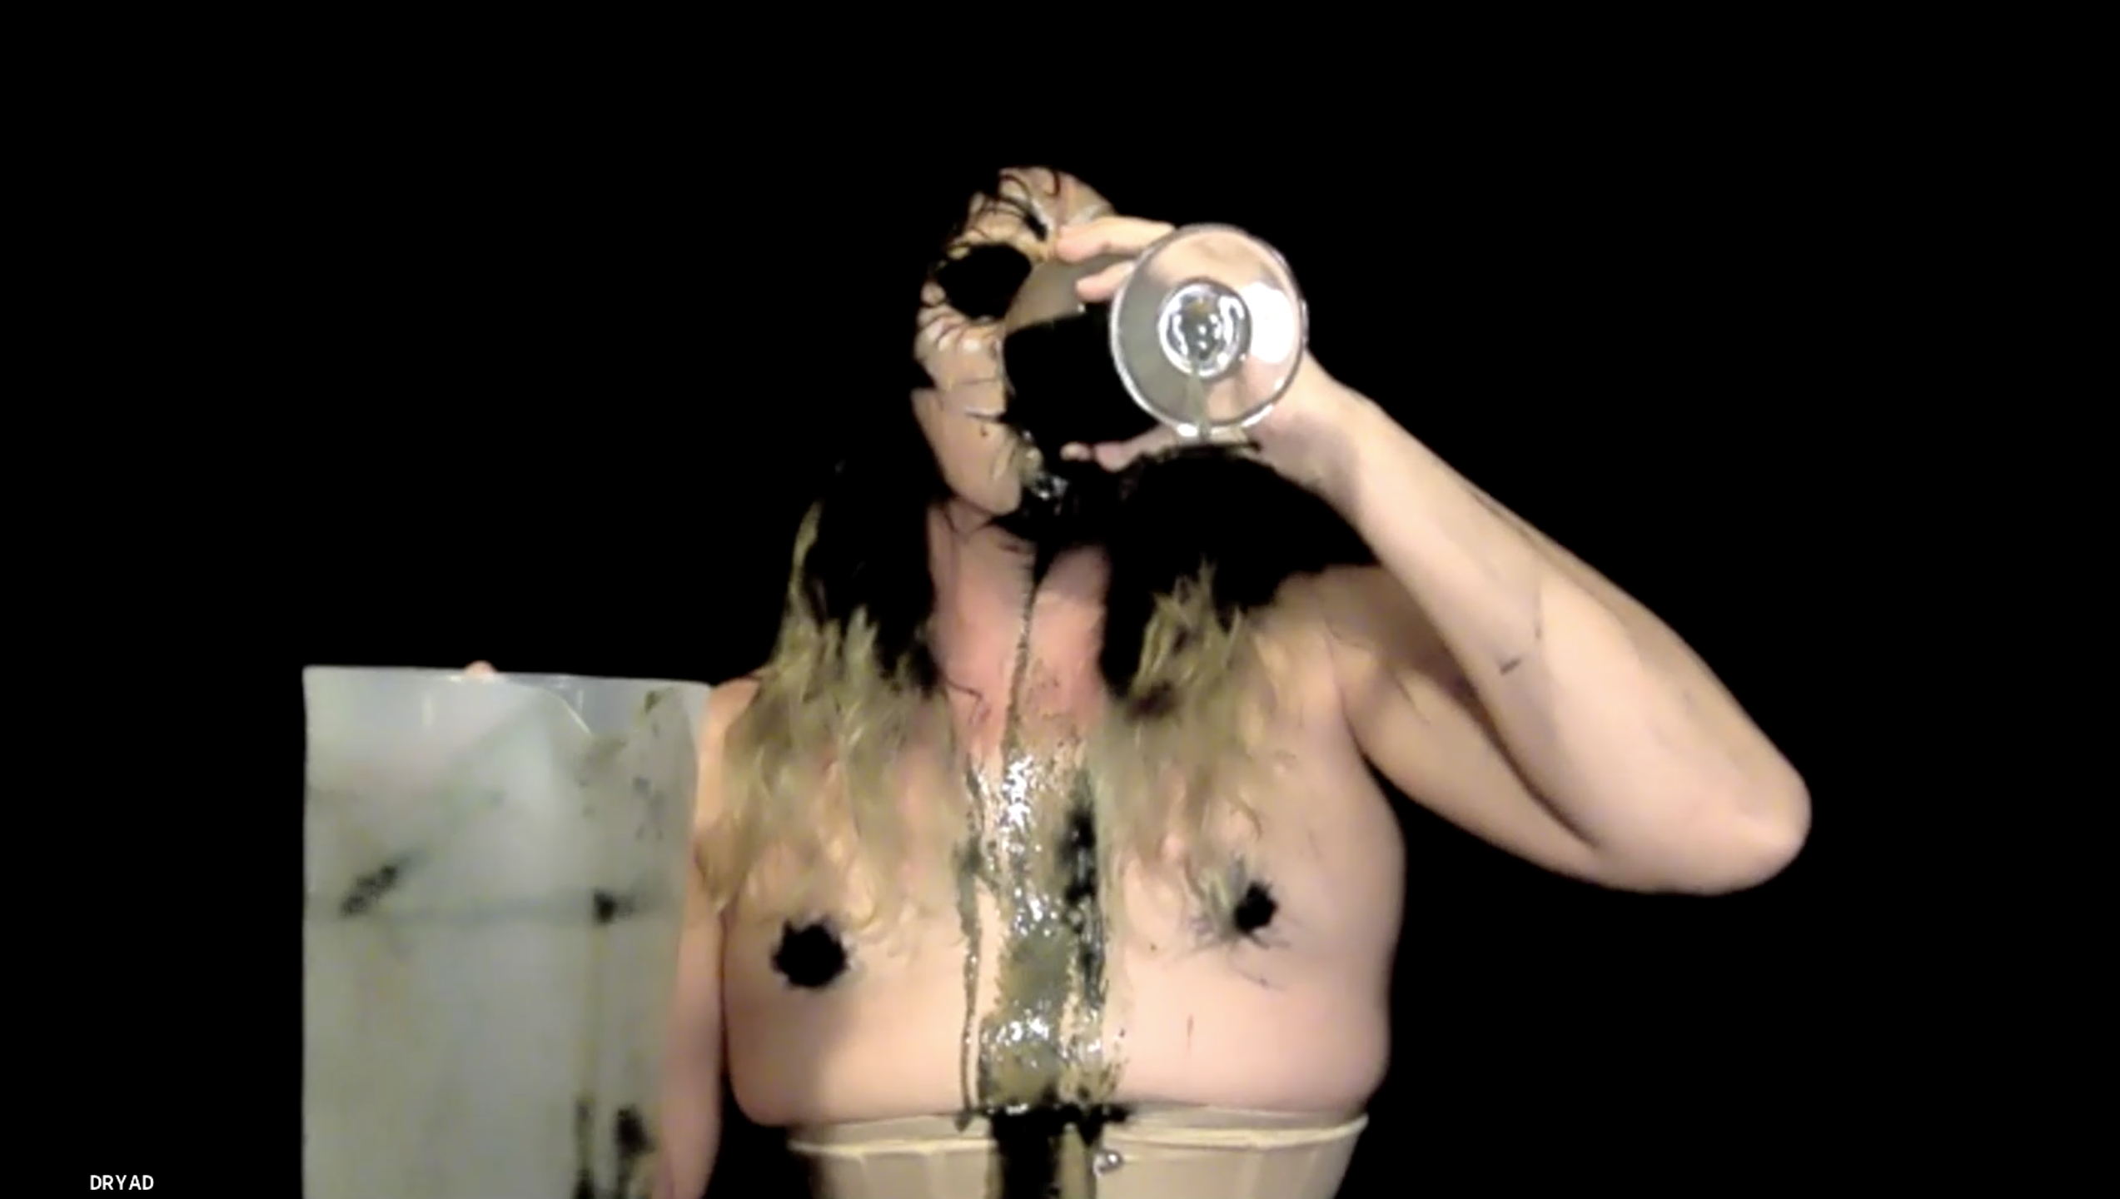
The most recent addition to the DRYAD EATS archive was a live digital performance over Zoom, Take A Drink (2020), which involved the Dryad playing a demented drinking game with her audience. A set of inquiries was made to the participants in the Zoom meeting, all preceded by the phrase, “Take a drink if…” with remarks ranging from the deeply philosophical and poetic to the frivolous and ridiculous. No matter the cue, Dryad always had to take a drink from her enormous container of unidentifiable gray goo. This interaction posed unexpected questions of honesty, identity, community, and culpability. To ambiguous statements, such as, “Take a drink if you are currently, or ever have been, a flower,” multiple individuals were inclined to imbibe with the Dryad. At other times, everyone would be forced to quietly watch as she would slowly drink up every drop of the thick liquid from her glass. And at another moment, the Dryad would coerce all audience members to drink, insisting that they all qualified for that particular cue. This performance and seeing people’s eagerness to relate to the Dryad, to understand who or what she is, why she is, and the effects it has on them to be participating in the excruciating acts she endures all were incredibly significant to me. Directly following the last drinking cue, I vomited for thirty minutes off-screen.
Take A Drink, live digital performance, 2020

I’m now sitting in the months that followed that piece, anxious and excited about the future of my work. With the experience and feedback that came from that performance, and the responses to my recent video work, I’m motivated to create more in this same vein, to create art that engages audiences (directly or indirectly), makes them laugh, makes them reflect on their personal and collective hardship, and forces them to consider their position of power and culpability within the current ecological crisis. As this series continues, I’m attempting to address a need for more tangible information-sharing alongside the more abstract or subversive references. Part of that involves my growing understanding of the role that my teaching practices play in my studio work.
In the last year, my dedication to expanding my pedagogical research has increased significantly. I’m incredibly lucky and grateful to be able to teach while in my graduate program. I want to ensure that I’m an effective educator since it’s a part of my daily life and would like to continue in higher education long after I leave this institution. In studying the work and literature of folks like bell hooks, Paulo Freire, Allan deSouza, and the like, I’ve begun to develop my own teaching philosophy and preferred pedagogical tactics. Like Marx, I seek to rescue education from the influence of the ruling class, and I aim to adopt decolonial values that challenge disciplining powers. The interactions I have with my students, the collaborative learning that occurs in the classroom, are all informing my understanding of my art and how I want it to function for my audiences.
Some larger, more complex ideas will need to be broken up and synthesized through multiple works. Others will be more immediately gratifying, easily discernible, and will perhaps even relate directly to the daily concerns of viewers. Dryad is, in her curious way, presenting a curriculum to her audience on anti-imperialist and decolonial justice for the Earth and its inhabitants. Over whatever span of time Dryad remains in my life and on this plane of existence, she and I will facilitate learning and empowerment and joy and dread and disgust and fantasy and hope and ferocity through our work together.
I foolishly came into grad school thinking that I’d see my partnership with the Dryad come to a close by the time my program was over. However, it’s clear now that whatever my thesis show culminates in materially will only be the beginning of a much larger body of work between us. There is so much potential in the malleability of her physical form and her energy as time unfolds and historical changes take place for better or for worse. A project that I am eager to see to fruition is an unorthodox graphic novel that chronicles Dryad’s journey towards ecological revolution. On a more immediate scale, I’m aiming to create at least three more DRYAD EATS videos/performances in the next year, with more “educational elements” embedded into them than there have been in prior works. These additions would be characterized by more concrete allusion to socio-political and ecological welfare, speaking on specific issues or historical references, and will be employed, in part, in a manner which satirizes or misappropriates educational television/media programs. I’m also currently experimenting with garments that are constructed to impede the Dryad or inform the encumbering/enduring action taking place in the performances.
I will concede; we are at a critical juncture in the age of humanity, in the era of the Anthropocene/Capitalocene/Chthulucene. The climate crisis has reached beyond our grasp with insurmountable losses in biodiversity and habitable environments. Our marginalized and most vulnerable peoples face explicit violence at the hands of corrupt governments and dogmatic fearmongers. In every other facet of our lives, late-stage capitalism distorts, destroys, and drains us down to our core. It is so easy to slip into despair…and yet we find ourselves in the middle of a movement for radical hope, strength, togetherness, and an unwillingness to give up on a better tomorrow. How inspiring it is to be a part of such a resilient community of activists, scholars, artists, and workers, and to be making my work in conjunction with this much grander global initiative. While I am largely influenced by the visual personification of the harsh, horrifying realities we face, I maintain that my outlook is generally positive when considering the future of our planet, the caveat being that the future is truly in our collective hands right now at this very moment. As Audre Lorde said, “Change is the immediate responsibility of each of us, wherever and however we are standing, in whatever arena we choose.” What we decide to do (or not do) will have a significant impact on the generations to follow us. So, we continue to fight, to create, to learn, to share, to heal, because we must (I must).
Works Cited
Aguilar-Moreno, Manuel. 2007. Handbook to life in the Aztec world. Oxford: Oxford University Press.
Bennett, Jane. 2010. Vibrant matter: A political ecology of things. Durham: Duke University Press.
Butler, Octavia E. 1989. Lilith’s brood. New York: Warner Books.
Cornejo, Kency. 2013. “Indigeneity and decolonial seeing in contemporary art of Guatemala.” FUSE 36-4, 24-31.
deSouza, Allan. 2018. How art can be thought: A handbook for change. Durham: Duke University Press.
Fanon, Frantz. 2004. The wretched of the earth. New York: Grove Press.
Lorde, Audre. 1984. “Learning from the 60s.” In Sister outsider, 134-144. New York: Crossing Press.
Marris, Emma. 2011. Rambunctious garden. New York; London: Bloomsbury.
Marx, Karl and Friedrich Engels. 1998. The communist manifesto. New York: Signet Classics.
Morton, Tim. 2016. Dark ecology: For a logic of future coexistence. New York: Columbia University Press.
Shelley, Mary. 1998. Frankenstein. Oxford; New York: Oxford University Press.
Waters, John. 1972. Pink Flamingos. Film. Baltimore: Dreamland.

Jane Bennett, Vibrant Matter: A Political Ecology of Things (Durham: Duke U Press, 2010), preface, ix.
Tim Morton, Dark Ecology: For a Logic of Future Coexistence (New York: Columbia U Press, 2016), 160.
Kency Cornejo, “Indigeneity and Decolonial Seeing in Contemporary Art of Guatemala,” FUSE 36-4, 2013, 24-31. This is a subject in much of Cornejo’s work, but I am pulling her ideas largely from this text.
The 1968 Earthworks exhibition at the Dwan Gallery in New York, NY introduced site-specific projects into the space with photographic documentation and material installations.
Manuel Aguilar-Moreno, Handbook to Life in the Aztec World (Oxford: Oxford U Press, 2007), 137-175. My research on this topic and within this text mainly centered on Azteca goddess, Coatlicue, She of the Serpent Skirt. In Mexica mythos, her body is the land beneath our feet and as she sacrificed to give the Aztec people life, so must they relinquish their bodies to her at their deaths. Many other Indigenous societies have similarly recognized the creative and destructive potentials of natural forces and processes.
The Locus amoenus is a literary topos involving an idealized place of safety or comfort. A locus amoenus is usually a beautiful, shady lawn or open woodland, or a group of idyllic islands, sometimes with connotations of Eden or Elysium.
Emma Marris, Rambunctious Garden (New York; London: Bloomsbury, 2011), 171.
Frantz Fanon, The Wretched of the Earth (New York: Grove Press, 2004), 181.
Octavia E. Butler, Lilith’s Brood (New York: Warner Books, 1989). From the Xenogenesis Trilogy, the Oankali are powerful extraterrestrial beings who are singularly driven by a carnal desire to heal, to experience that which is unknown to them, and to merge genetically with endangered species. The Oankali involve themselves in the salvation of a nearly extinct humanity from a dead Earth and bring about a new world to be shared with uncanny alien creatures: humankind’s own children.
Mary Shelley, Frankenstein (Oxford; New York: Oxford University Press, 1998).
Morton, Dark Ecology, “The Third Thread,” 144.
A mukbang is an online audiovisual broadcast in which a host consumes large quantities of food while interacting with the audience. It became popular in South Korea in 2010, and since then has become a huge worldwide trend.
Pink Flamingos, directed by John Waters (1972; Baltimore, MD: Dreamland), Film.
Karl Marx and Friedrich Engels, The Communist Manifesto (New York: Signet Classics, 1998), 88.
Influenced greatly by the teaching philosophy and principles of Allan deSouza in How Art Can Be Thought.
Audre Lorde, “Learning from the 60s,” in Sister Outsider (New York: Crossing Press, 1984), 141.

